Full Subtractor :-
A combinational logic circuit used to subtract three binary digit at a time is called full subtractor.
This circuit has three input and two outputs. The three inputs are A , B and Bin , denote the minuend , subtrahend and previous borrow respectively. The two outputs , D & Bout represent the difference and output borrow , respectively.

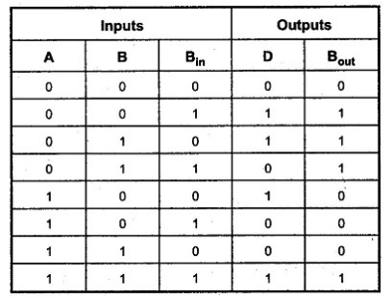
Truth table :-

K – Map for D K – Map for Bout
